Garfield County
Voluntary Stewardship Practice Checklist

Voluntary Stewardship Program Overview

What is a Voluntary Stewardship Program (VSP)?
VSP is a new, non-regulatory, and incentive-based approach that balances the protection of critical areas on agricultural lands while promoting agricultural viability. VSP is allowed under the Growth Management Act as an alternative to traditional approaches to critical areas protection, such as “no touch” buffers. Garfield County is one of 28 counties that has “opted in” to VSP receiving funding to develop a VSP Work Plan and future implementation funding.

What is meant by “Voluntary Participation” in VSP?
VSP is voluntary; agricultural landowners and operators (commercial and noncommercial) are not required to participate. Agricultural producers who choose to participate are free to withdraw at any time without penalty. Separate from VSP, landowners are expected to comply with any new or existing contractual agreements under government or other programs for which they have obligated themselves for implementing projects. Agricultural producers who do not formally participate in VSP are not required to take actions to protect critical areas. The Garfield County VSP Work Plan can remain viable at the County level, even without full landowner participation, if the County is meeting protection goals and benchmarks. However, agricultural producers are encouraged to avoid impacts to critical areas, and other applicable laws and regulations still apply (such as clean water act, federal wetland protections, and endangered species act and state hydraulic project approvals).

Why should you participate?
VSP allows farmers and ranchers more flexibility than traditional critical area regulations however, it is not a replacement for other state and federal regulations. VSP allows tailoring of voluntary practices to individual farms and ranches for critical area protection and agriculture viability. It is the intent of the Garfield VSP Work Group to protect private property rights with a locally led Work Plan.

What is a “Farm Stewardship Plan?”
A Farm Stewardship Plan is an implementation tool developed by the Garfield VSP Work Group to help technical leads and agricultural producers identify the potential presence of critical areas on a farm and develop a plan to protect critical areas based on voluntary participation. A Farm Stewardship Plan Checklist is included to help facilitate the development of Farm Stewardship Plans by identifying examples of practices and programs that further the goals and benchmarks of this Work Plan.
Conservation practices included in a Farm Stewardship Plan do not necessarily need to meet Natural Resources Conservation Service or other government-based standards for practices, unless enrolled in a specific agency program or agreement. Farm Stewardship Plans should:
- Identify the presence of critical areas
- Identify existing practices that may protect and/or enhance critical areas
- Identify additional voluntary opportunities to protect and/or enhance critical areas
Additionally, Farm Stewardship Plans will help assist the Work Group report progress on the Work Plan goals and benchmarks for VSP participation and critical areas protection during the implementation phase of VSP.

What is meant by “Baseline Conditions?”
The effective date of the VSP legislation is July 22, 2011. Per the law, this is the date that identifies the baseline for protecting critical areas functions and maintaining agricultural viability. Per VSP legislation:
- Implementation of this Work Plan must prevent further degradation of critical areas functions as they existed on July 22, 2011, while maintaining agricultural viability. Goals for enhancement of critical areas functions must also be identified.
- Failure to meet the goals and benchmarks for critical area functions will represent failure of the Work Plan and trigger a regulatory approach to critical areas protection under the GMA.

What are Critical Areas?
Critical areas perform key functions that enhance our environment (e.g., clean water and fish and wildlife habitat) and provide protection from hazards (e.g., floods and excessive erosion). Critical areas defined under the State’s Growth Management Act (RCW 36.70A) include: 1) Wetlands, 2) Fish and Wildlife Habitat Conservation Areas, 3) Critical Aquifer Recharge Areas, 4) Geologically Hazardous Areas, and 5) Frequently Flooded Areas.

What does it mean to “Protect and Enhance Critical Areas?”
VSPs require creation of measurable benchmarks that are designed to protect and enhance critical area functions and values (e.g., shade, cover, or water flow into a wetland) through voluntary actions by agricultural producers while maintaining agricultural viability. Per VSP definitions:
- Protection requires prevention of the degradation of functions and values of baseline conditions (conditions existing as of July 22, 2011, when VSP legislation was passed).
- Enhancement means to improve the processes, structure, and functions of baseline conditions for ecosystems and habitats associated with critical areas.

Critical Area Functions?
Critical areas provide important ecological functions and values. These have been summarized into four primary functions.
Soil functions through the preservation of soil and the quality of the underground ecosystem, which preserves plants, animals and human life. Water Quality through water filtration and retention of fine sediment, excessive nutrients, and other pollutants, as well as maintaining temperature through canopy shade. Hydrology through the delivery, movement and storage of water. Fish and Wildlife Habitat through the natural environments in which species or populations live.

Objectives of the VSP Checklist?
The Checklist is intended to help farmers and ranchers:
- Identify the potential presence of critical areas on or down-gradient of farm
- Protect Critical Areas by:
  - Maintaining or enhancing existing farm practices
  - Identifying opportunities to implement additional practices on land and connecting with technical service providers for farm programs, practices and cost-share if interested
- Document existing practices implemented prior to 2011 and during VSP Implementation
Information collected by producers using this checklist will be used to quantify, at the County level, stewardship measures that have been implemented and associated critical areas protection and enhancement benefits as well as maintaining and improving agriculture viability.

Garfield County Critical Area Examples
Wetlands – 350 acres  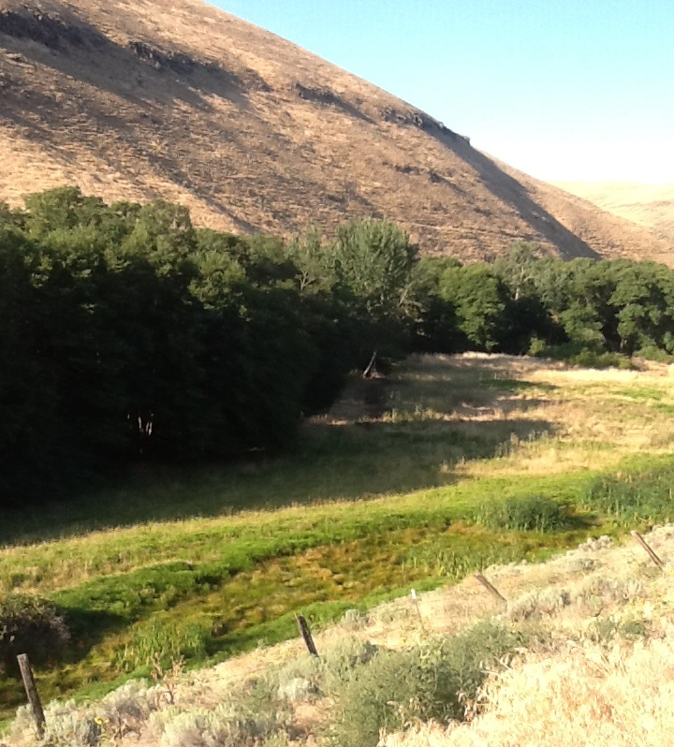 | Wetland are areas inundated or saturated by surface water or groundwater for at least part of the growing season and support vegetation adapted for life in saturated soil conditions.  Critical Area Functions: Water quality, hydrology and fish and wildlife habitat.  Includes: swamps, marshes, bogs and in some instates springs. Potential Locations: wetlands located in riparian, agricultural and rangeland areas.
Fish and Wildlife Habitat Conservation Areas (FWHCAs) – 120,640 acres  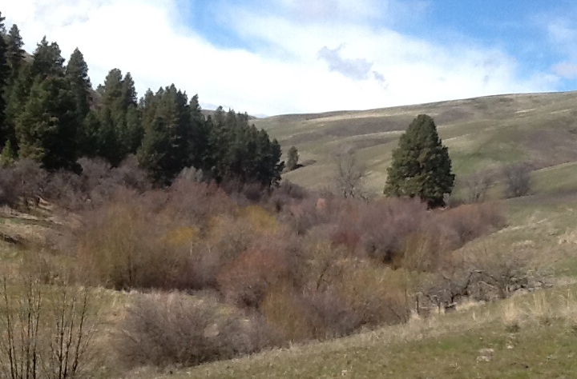 | FWHCAs are land and water that provide habitat for fish and wildlife species.  Critical Area Functions: Water quality, soil, hydrology and fish and wildlife habitat.  Includes: streams and rivers with ESA listed steelhead and riparian, agricultural and rangeland areas that support breeding grounds, winter range and corridors for migrating species. Including food, water, cover and shelter in all these areas.  Target Species: steelhead, mule deer, upland game birds, and raptors.  Potential Locations: FWHCA’s in instream, riparian, agriculture, rangeland, cliffs and bluffs areas.
Critical Aquifer Recharge Areas (CARAs) – 140 acres | CARAs have a critical recharging effect on aquifers used for drinking water, including vulnerable aquifers vulnerable that could reduce supply by reducing recharge rates and water availability.  Critical Area Functions: Water quality and hydrology  Includes: areas adjacent to city wells, shallow groundwater areas and areas identified to have connection to aquifers.  Potential Locations: CARA’s occur within instream, riparian, Ag and rangeland areas.
Geologically Hazardous Areas (GHAs) – 253,790 acres  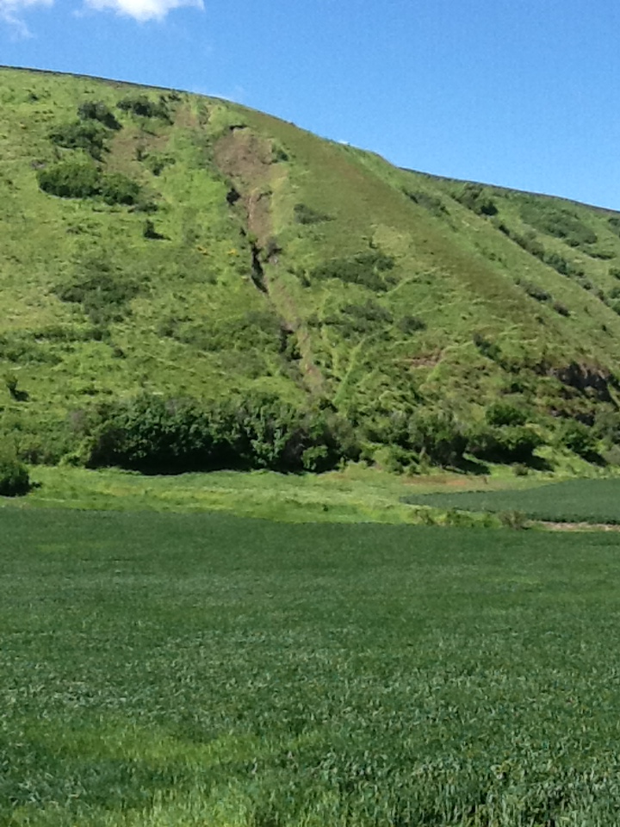 | GHAs are susceptible to erosion, sliding, and other geological events. GHAs, related to agricultural activities, are primarily associated with erosion, which include moderate to very severe water erosion potential areas. Wind erosion is another source.  Critical Area Functions: Water quality, soil, hydrology, and fish and wildlife habitat.  Includes: landslides hazard areas, channel migration zones, steep slopes (>40%) and highly erodible soils.  Potential Locations: GHA’s areas occur within Ag and rangeland areas.
Frequently Flooded Areas (FFAs) – 5,050 acres  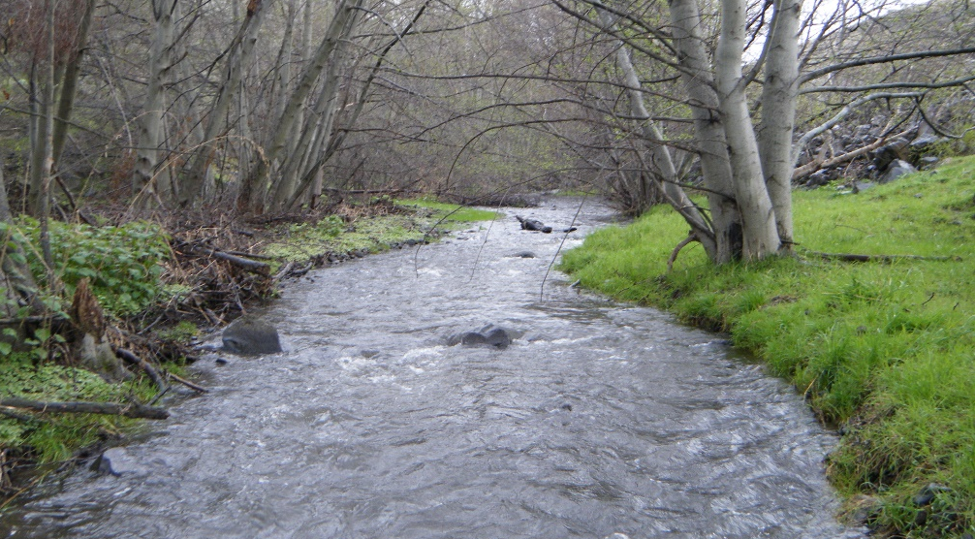 | FFAs includes 100-year floodplains and floodways, and often include the low-lying areas adjacent to rivers that are prone to inundation during heavy rains and snowmelt.  Critical Area Functions: Water quality, soil, hydrology and fish and wildlife habitat.  Includes: streams, rivers, lakes, wetlands, and areas where ground water can cause flooding.  Potential Locations: frequently flooded areas occur within instream, riparian, agriculture and rangeland areas.

What does it mean to “Maintain Agricultural Viability?”
The Work Plan must protect critical areas and maintain agricultural viability. Activities or methods that protect critical areas also must be beneficial to farm operations. Further, the VSP will not require an agricultural producer to discontinue agricultural activities that legally existed before July 22, 2011. Agricultural viability is discussed further in Section 3.
VSP is intended to balance critical areas protection and agricultural viability through voluntary actions by Ag producers. VSP is not a replacement for compliance with other laws and regulations, but participation in the program can often help agricultural producers comply with these requirements.
Balanced Approach of Critical Areas Protection and Agricultural Viability
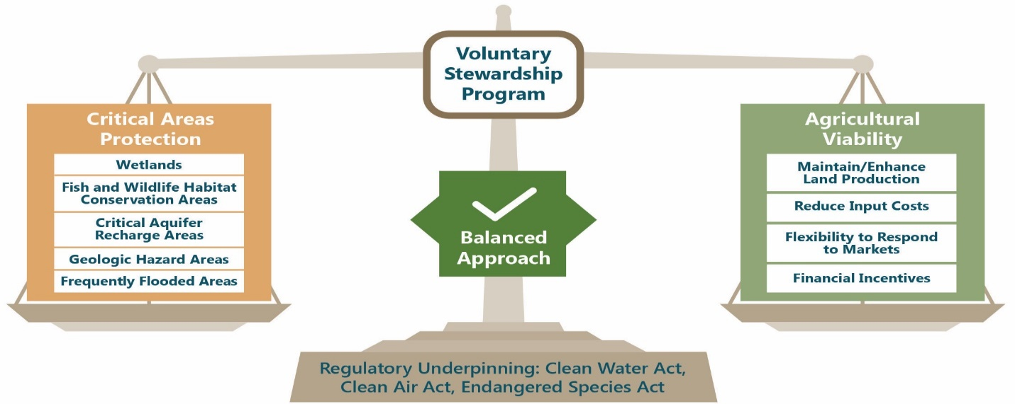
VSP Checklist: Practices on Your Farm?
Practices may fall under multiple types; please include each practice implemented only once. Also, please note the intent of this checklist is to document all practices implemented, whether your received cost-share or if they met Natural Resource Conservation Service (NRCS) standards. Practices can be directly or indirectly protecting and/or enhancing critical areas.
Practices Currently on Your Farm or Ranch? or What are You Interested in Implementing?
Some landowners/producers/operators may implement numerous conservation practices and are encouraged to consider which additional practices may fit within their operations, while maintaining the viability of farming and ranching and voluntarily protecting critical areas. The tables below are not all-inclusive and are meant to be flexible and allow for any management practices regardless of whether it meets NRCS standards and specifications. Priority will be given to proven practices, but if the Work Group agrees and there are benefits to both critical areas and long-term viability of agriculture any practice will be evaluated and ranked for future implementation funding and reporting.
The following tables for Soil Management, Residue and Tillage Management, Water Management and Filtration, Chemical and Nutrient Management, Livestock Management, Upland Habitat and Instream Habitat Management and Other Management Practices are for documenting what is currently occurring on your farm and/or ranch and will be used as a farm assessment tool for potential future reporting on the status of identified critical areas and also what voluntary actions may be taken to not only protect identified critical areas but also maintain long-term agriculture viability on individual farms.
Page 12 has a table of voluntary practice examples that may have incentives or cost-share available in Garfield County. This table is not all-inclusive since new and emerging practices may not be listed, but is intended as a starting point for farmers and ranchers to identify potential practices that may have a place in current or future management objectives for maintain agriculture and voluntarily protecting identified critical areas.

Garfield VSP Checklist
Soil Management Practices
Existing Practices: | Types of Practices: Cover Crop, Range Plantings, Sediment Basin, Gully Plugs,  Others?
 | Acres: Feet of fence:
 | Critical Area Nearby?  (within 500 feet) | Circle those that Apply:  Yes No Maybe Don’t Know
 | If Yes, Provide Critical Areas:
Future Practice Interest: | Potential Practices: Cover Crop, Range Plantings, Sediment Basin, Gully Plugs,  Others?
Residue and Tillage Management Practices
Existing Practices: | Types of Practices: Direct Seed, 2-Pass, Reduced Till, Precision Agriculture,  Others?
 | Acres:
 | Critical Area Nearby?  (within 500 feet) |  | Circle those that Apply:  Yes No Maybe Don’t Know
 | If Yes, Provide Critical Areas:
Future Practice Interest: | Potential Practices: Direct Seed, 2-Pass, Reduced Till, Precision Agriculture,  Others?

Garfield County VSP Checklist
Water Management and Filtration Practices
Existing Practices: | Types of Practices: Grassed Waterway, Filter Strips, Terraces, Sediment Basins, Gully Plug,  Others?
 | Acres:
 | Critical Area Nearby?  (within 500 feet) | Circle those that Apply:  Yes No Maybe Don’t Know
 | If Yes, Provide Critical Areas:
Future Practice Interest: | Potential Practices: Grassed Waterway, Filter Strips, Terraces, Sediment Basins, Gully Plug,  Others?
Chemical and Nutrient Management Practices
Existing Practices: | Types of Practices: Nutrient Management, Pest Management,  Others?
 | Acres:
 | Critical Area Nearby?  (within 500 feet) | Circle those that Apply:  Yes No Maybe Don’t Know
 | If Yes, Provide Critical Areas:
Future Practice Interest: | Potential Practices: Nutrient Management, Pest Management,  Others?

Garfield County VSP Checklist
Livestock Management Practices
Existing Practices: | Types of Practices: Prescribed Grazing, Range Planting, Fence, Watering Facility,  Others?
 | Acres: Feet of fence:
 | Critical Area Nearby?  (within 500 feet) | Circle those that Apply:  Yes No Maybe Don’t Know
 | If Yes, Provide Critical Areas:
Future Practice Interest: | Potential Practices: Prescribed Grazing, Range Planting, Fence,  Watering Facilities, Others?
Upland Habitat Management Practices – Wildlife
Existing Practices: | Types of Practices: Conservation Cover, Windbreak, Range, Tree/Shrub Plantings, Others?
 | Acres:
 | Critical Area Nearby?  (within 500 feet) |  | Circle those that Apply:  Yes No Maybe Don’t Know
 | If Yes, Provide Critical Areas:
Future Practice Interest: | Potential Practices: Conservation Cover, Windbreak, Range, Tree/Shrub Plantings, Others?

Garfield County VSP Checklist
Instream Habitat Management Practices - Fish
Existing Practices: | Types of Practices: Post Assisted Log Structures, Beaver Dam Analogs, Streambank Protection, Others?
 | Number of Structures:
 | Critical Area Nearby?  (within 500 feet) | Circle those that Apply:  Yes No Maybe Don’t Know
 | If Yes, Provide Critical Areas:
Future Practice Interest: | Potential Practices: Post Assisted Log Structures, Beaver Dam Analogs, Streambank Protection, Others?
Other Management Practices
Existing Practices: | Types of Practices:
 | Acres: Feet of fence:
 | Critical Area Nearby?  (within 500 feet) | Circle those that Apply:  Yes No Maybe Don’t Know
 | If Yes, Provide Critical Areas:
Future Practice Interest: | Potential Practices:

Voluntary Practice Examples
Stewardship Practices  Type Example Practice |  | Critical Areas Function |  |  |  | Agricultural Viability
 |  | Water Quality | Hydrology | Soil Health | Habitat
Soil Management | Cover Crop  Reduced Till, No-Till/Direct Seed, Precision Ag  Fuel Reduction with thinning and pull back on save trees for timberlands | ● | ● | ● | ● | - Soil quality and conservation  - Weed management  - Pollinator/beneficial organisms  - Increased yield and fertility  - Reduced input costs
Residue and Tillage Management | Reduce Till, No-Till/Direct Seed  Precision Ag | ● | ● | ● | ● | - Soil quality and conservation  - Weed management  - Increased yield and fertility  - Reduce input costs
Chemical and Nutrient Management | Nutrient Management  Integrated Pest Management  Precision Ag | ● |  | ● | ● | - Soil quality  - Weed management  - Increased yield and fertility  - Reduce input costs
Water and Filtration Management | Grassed Water Ways, Filter Strips, Terraces  Sediment Basins, Gully Plugs, Fuel Reduction with thinning and pull back on save trees for timberlands | ● | ● | ● | ● | - Soil quality and conservation  - Weed management  - Increased yield and fertility  - Reduce fuel loads
Range Management | Prescribe or Managed Grazing, Range Plantings, Fencing, Watering Facilities | ● | ● | ● | ● | - Soil quality and conservation  - Weed management  - Increased yield and fertility
Wildlife Habitat Management | Conservation Cover, Tree/Shrub Plantings  Range Plantings, Fencing, Off-Stream Water | ● |  | ● | ● | - Soil conservation  - Weed m anagement  - Increased yield and fertility
Riparian and Instream Habitat Management | Tree Planting, Soft Streambank Protection  Instream Habitat (PALS, BDAs, etc) | ● |  |  | ● | - Soil and water quality and conservation  - Weed Management  - Pollinator/beneficial organisms
Additional Information and Assistance for Producers:
Producers are encouraged to consider whether one or more practice fit within their operations to protect and/or restore critical areas within Garfield County while maintaining the long-term viability of farming and ranching. VSP Work Plan and Checklist information, technical assistance and potential cost-share is available from the following list:
Washington State Conservation Commission: Website: http://scc.wa.gov/
Garfield County: Website: http://co.garfield.wa.us/vsp/voluntary-stewardship-program
Garfield VSP Coordinator/Technical Assistance Providers:
Pomeroy Conservation District: Website: http://www.pomeroycd.com/
Garfield County Cattlemen’s Association: State Wide Website: http:///www.washingtoncattlemen.org/
Garfield County Wheat Growers Association: State Wide Website: http://www.wawg.org/
Pomeroy Grain Growers: Website: https://www.pomeroygrain.com/
Nez Perce Tribe Watershed Division: Website: http://nptfisheries.org/Divisions/Watershed.aspx
Snake River Salmon Recovery Board: Website: http://snakeriverboard.org/wpi/
Washington State Department of Ag: Website: https://agr.wa.gov/
Washington State Farm Bureau: Website: http://wsfb.com/
USDA Natural Resources Conservation Service: Website: https://www.nrcs.usda.gov/wps/portal/nrcs/site/wa/home/
Garfield County Farm Service Agency: Website: https://www.fsa.usda.gov/state-offices/Washington/index
Washington State University Extension: Website: http://extension.wsu.edu/

